4.6, 4.7 TEST ms
1. (a) (i) CH3CH=CH2 + HCl + AlCl3 → (CH3)2H (1) AlCl (1)
(ii) Type of substitution electrophilic or alkylation (1)
Mechanism
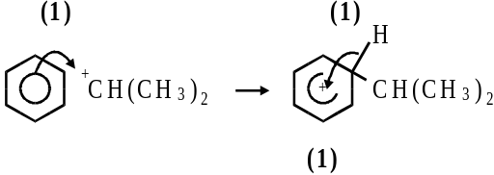 6
(b) CH3CH2CH or primary carbonium ion (1)
less stable or 1 & 2 inductive effects (1)
than (CH3)2CH+ or secondary (1) 3

(c) CH3CHClCH3 (1) 1
[10]

2. (a) ΔH = –119.6 × 3 (1)
= –358.8 kJ mol–1 (1)
(b) benzene is more stable or of lower energy (1)
due to delocalisation (1) 4
[4]

3. (a) Lone pair on N (1)
accepts a proton (1) 2
(b) Lone pair less available (1)
due to delocalisation (1) 2
(c) (i) Nucleophilic substitution or alkylation (1)
(ii) Compound 1 (CH3CH2)2NH (1)
Compound 2 (CH3CH2)3N (1)
Compound 3 (CH3CH2)4N+Br– 4
(d) Equation CH3CN + 2H2 → CH3CH2NH2 (1)
Reason only one product formed (1) 2
[10]

4. (a) (i) cone HNO3 1
cone H2SO4 1
allow 1 for both acids if either cone missing
HNO3 + 2H2SO4 → NO2+ + H3O+ + 2HSO4– 1
or HNO3 + H2SO4 → NO2+ + H2O + HSO4–
(ii) electrophilic substitution CH3 1
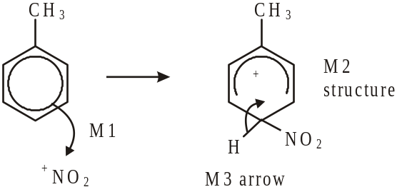
3
horseshoe must not extend beyond C2 to C6 but can be smaller
+ must not be too close to Cl
(b) Sn or Fe / HC1 (cone or dil or neither)
or Ni / H2 not NaBH4 LiAlH4 1
(c) (1) NH3 1
Use an excess of ammonia 1
(ii) nucleophilic substitution 1
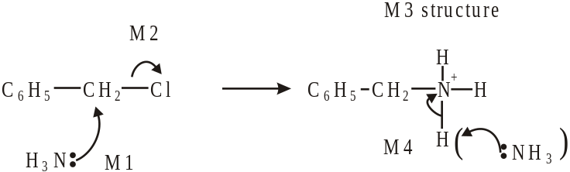
4
(d) lone pair on N less available (in correct context) 1
delocalised into the ring (Q of L) 1
(e)
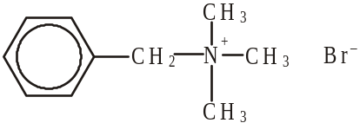
ignore Br
+ must be on N or outside a
square bracket 1
(f)
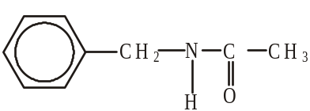 1
[19]

5. (a)
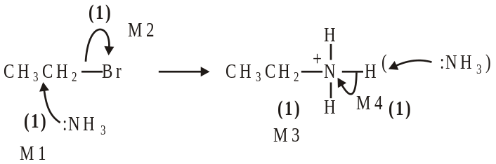
Further reaction / substitution / formation of II° / III° amines etc (1)
use an excess of NH3 (1) 6
(b) 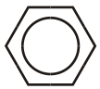 repels nucleophiles (such as NH3) (1) 5
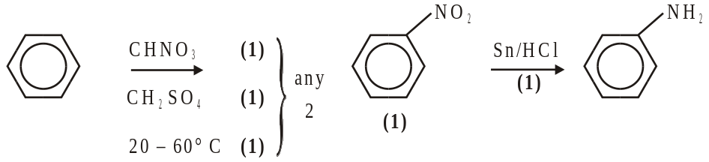
Notes
(a) allow SN1
penalise: Br– intead of NH3 removing H+ for M4
not contamination with other amines (this is in the question) not diamines
(b) allow because NH3 is a nuclephile or benzene is (only) attacked by electrophiles
or C–Br bond (in bromobenzene) is stronger / less polar or Br lp delocalized
HNO3 / H2SO4 without either conc scores (1) allow 20 – 60° for (1) (any 2 ex 3)
allow name or structure of nitrobenzene
other reducing agents: Fe or Sn with HCl (conc or dil or neither)
not conc H2SO4 or conc HNO3
allow Ni/H2
Not NaBH4 or LiAlH4
ignore wrong descriptions for reduction step e.g. hydrolysis or hydration
[11]

Organic points
(1) Curly arrows: must show movement of a pair of electrons,
i.e. from bond to atom or from lp to atom / space
e.g.
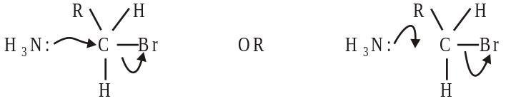
(2) Structures
penalise sticks (i.e. 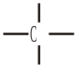) once per paper
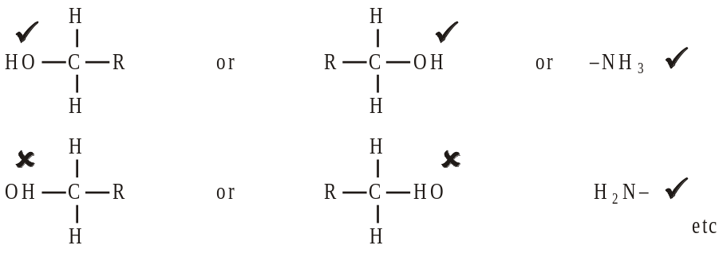
Penalise once per paper
allow CH3– or –CH3 or 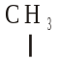 or CH3
or H3C–

